SNS and SQS

SNS and SQS with AWS Lambda
1. IAM Role Update
Ensure the Lambda role (lambda-ec2-stop-role) has the following permissions:

Iam policyCreate Policy
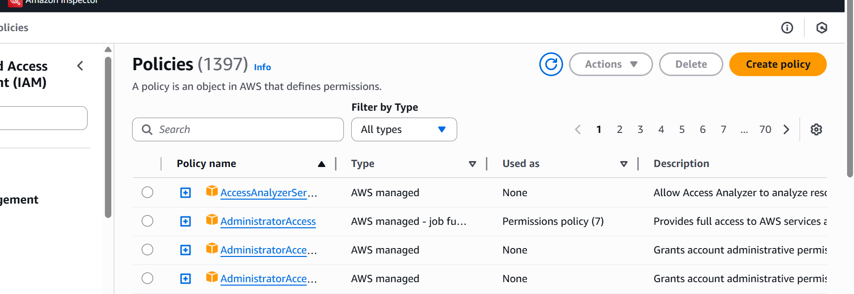

Copy and paste below json
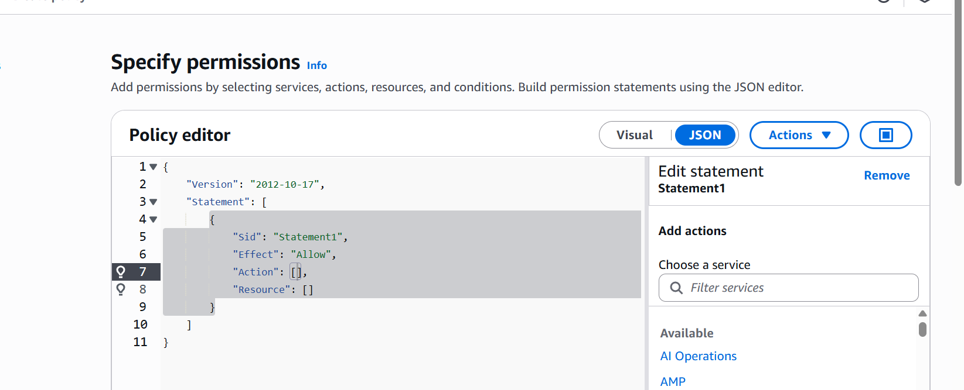

{
"Version": "2012-10-17",
"Statement": [
{
"Sid": "VisualEditor0",
"Effect": "Allow",
"Action": [
"ec2:DescribeInstances",
"ec2:DescribeRegions",
"ec2:StopInstances",
"rds:DescribeDBInstances",
"rds:StopDBInstance",
"sns:Publish",
"sqs:SendMessage"
],
"Resource": "*"
}
]
}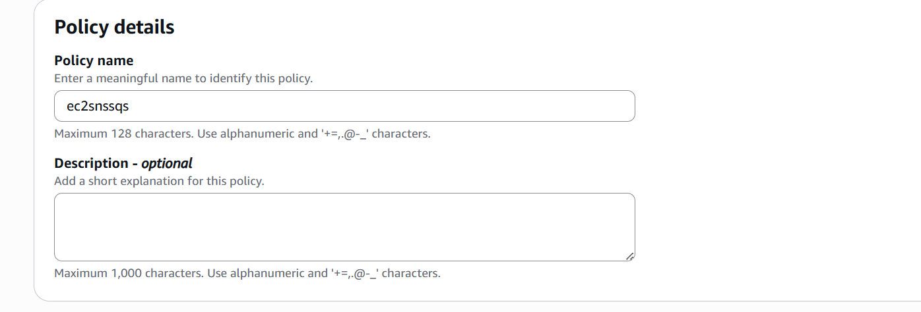

Create Role
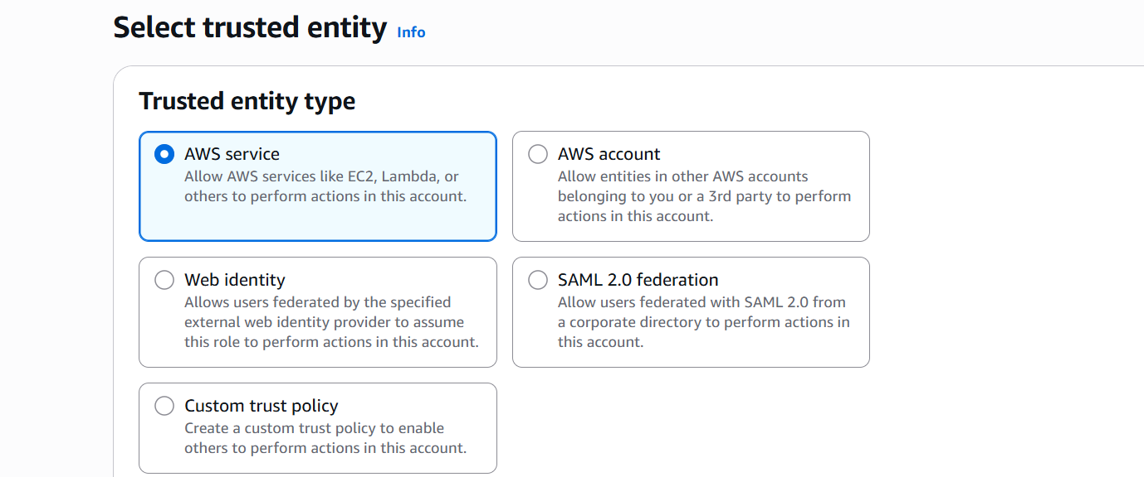
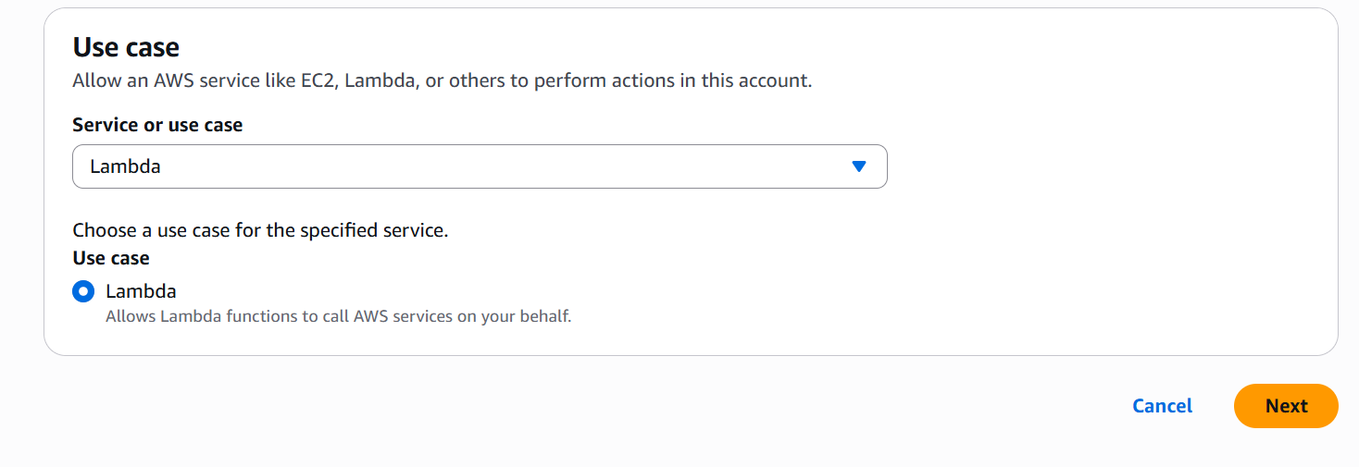

Select the policy
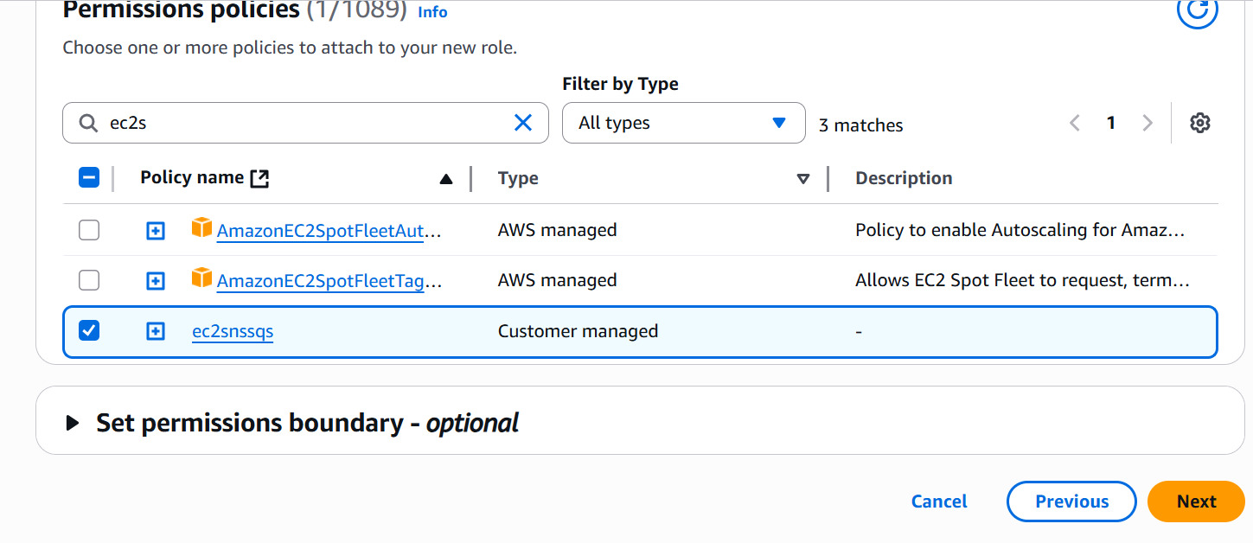
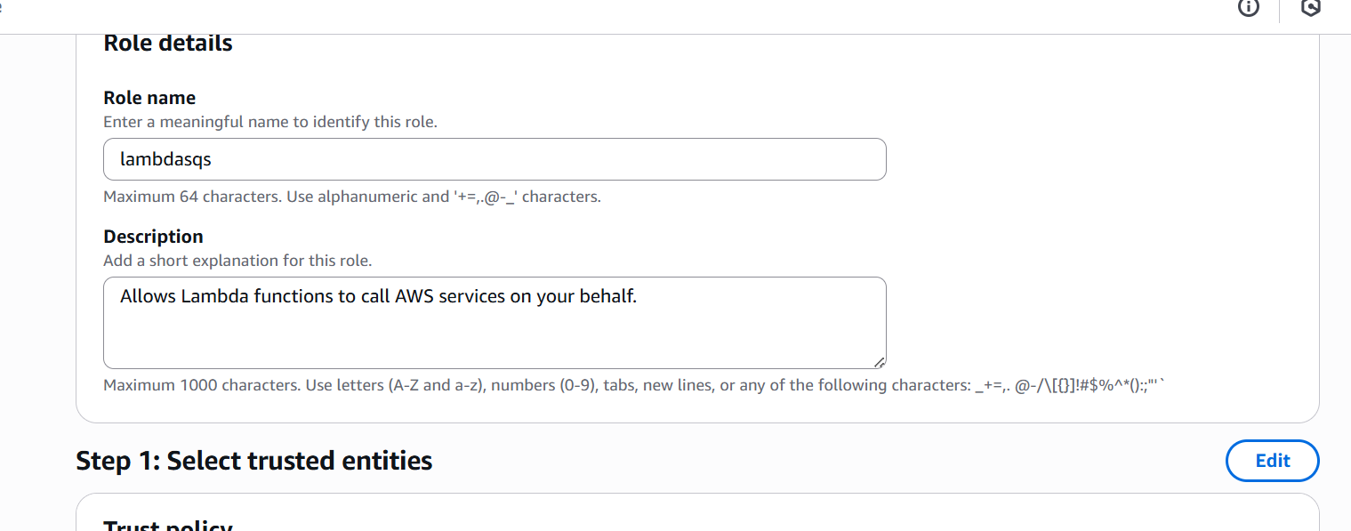

Create SNS
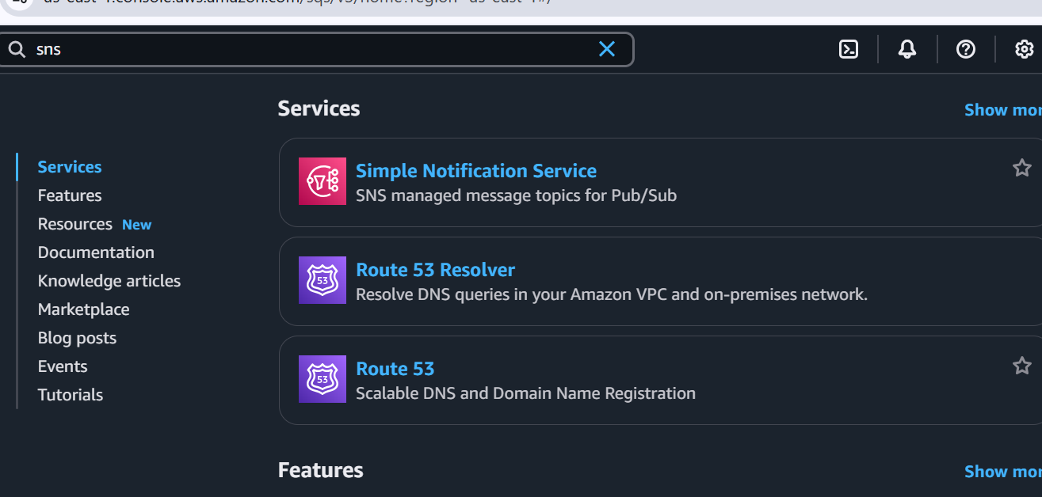

- Go to SNS → Topics → Create topic
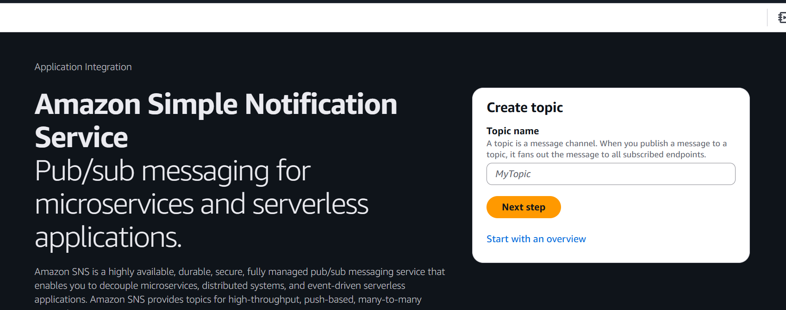
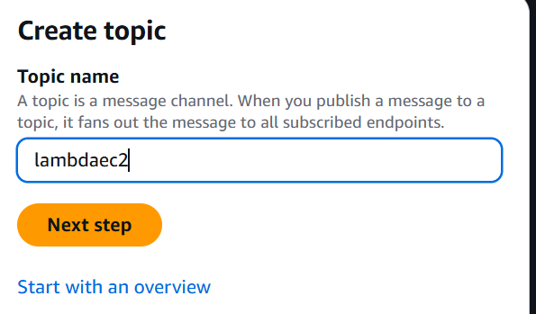

- Choose Standard queue
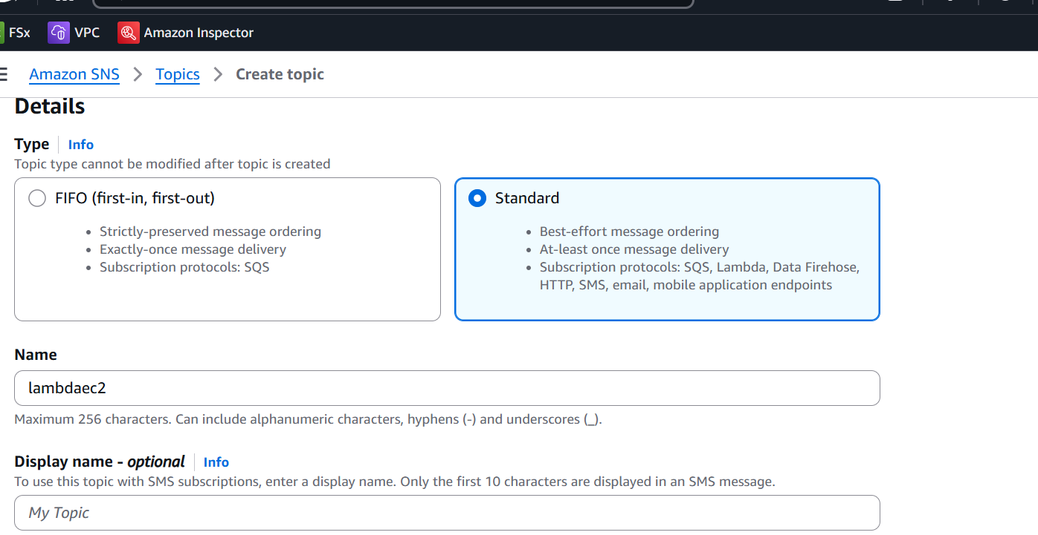

Create topic
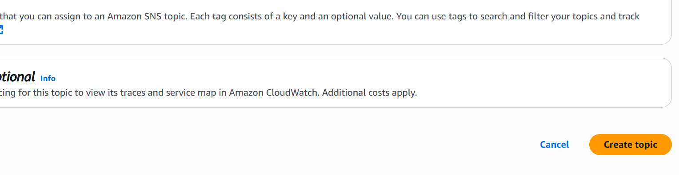

- Use Standard, name it, and copy the ARN.
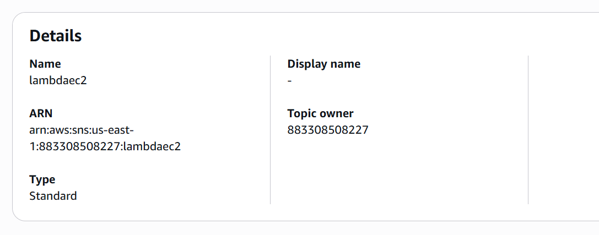

- Add a subscription (e.g., Email).
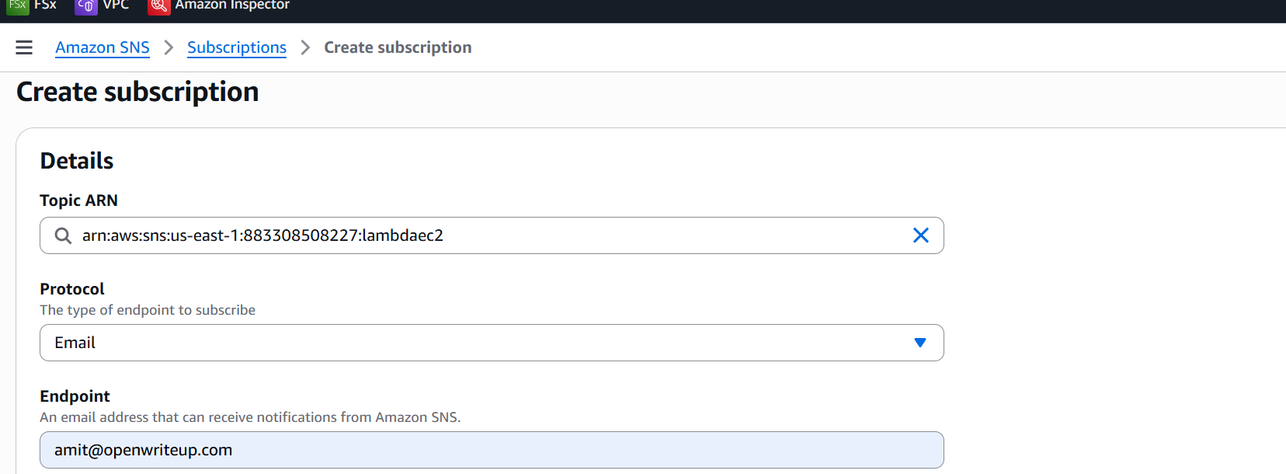

SQS Setup
- Go to SQS → Create Queue
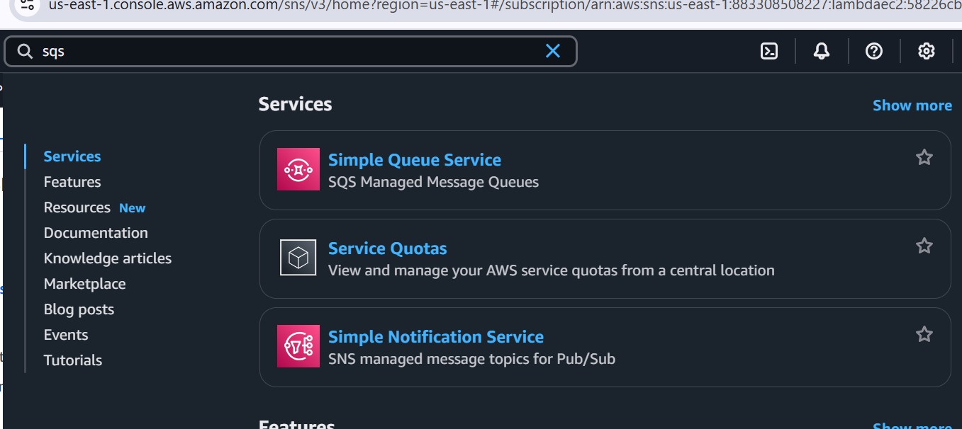
- Choose Standard queue
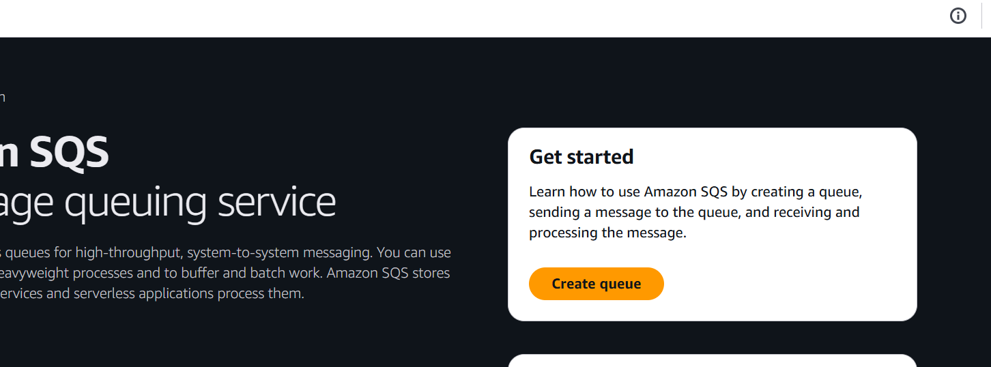

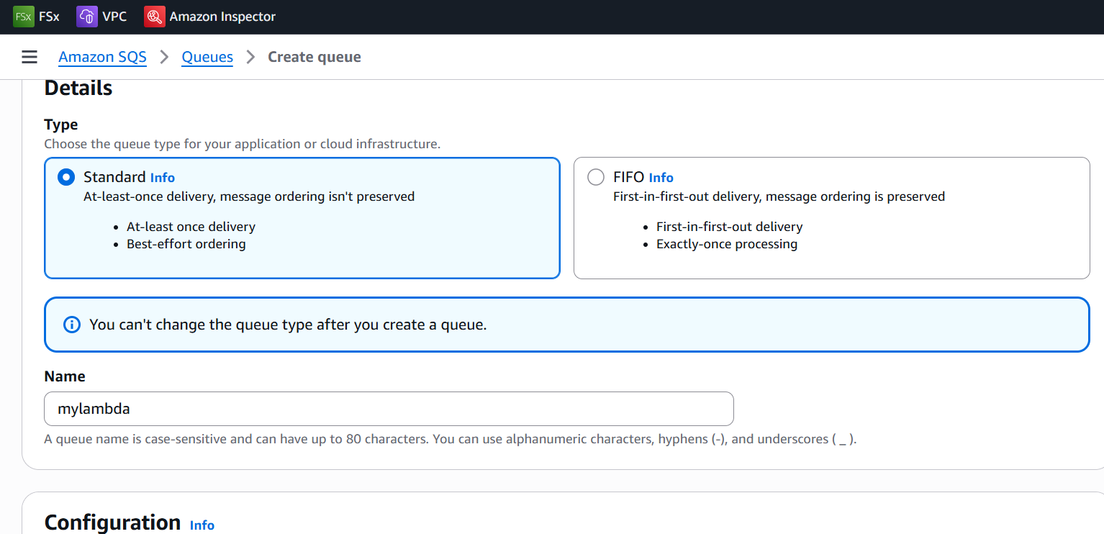
- Copy the Queue URL for use in the code.

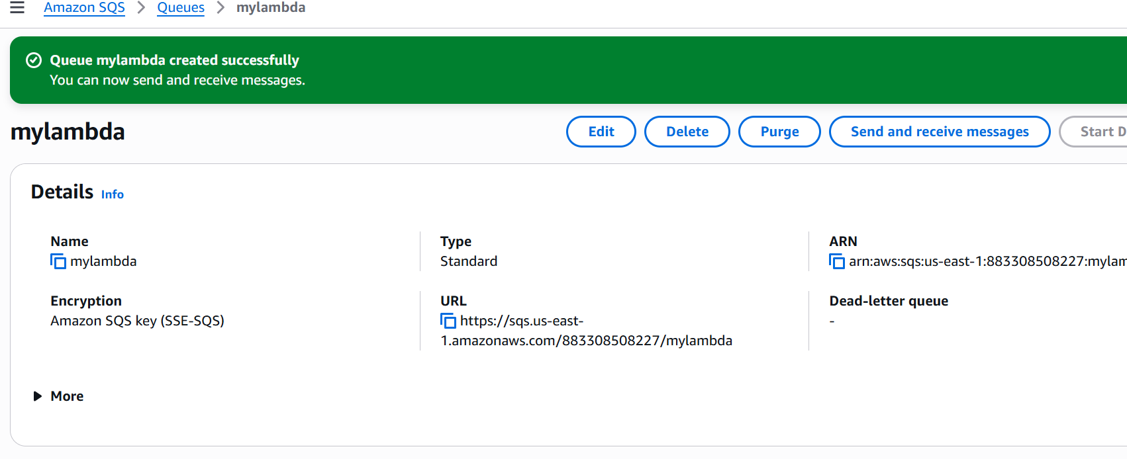

Lambda
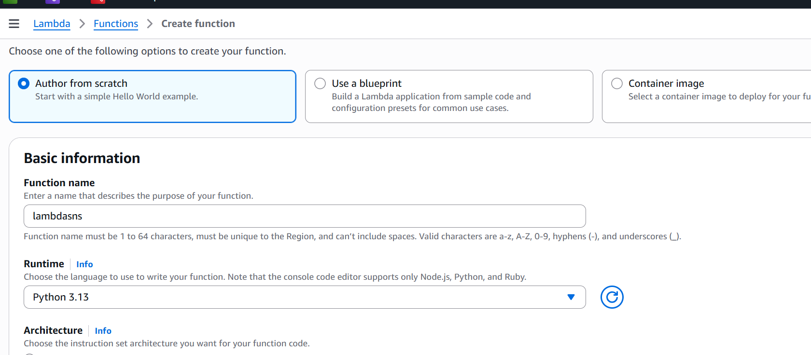
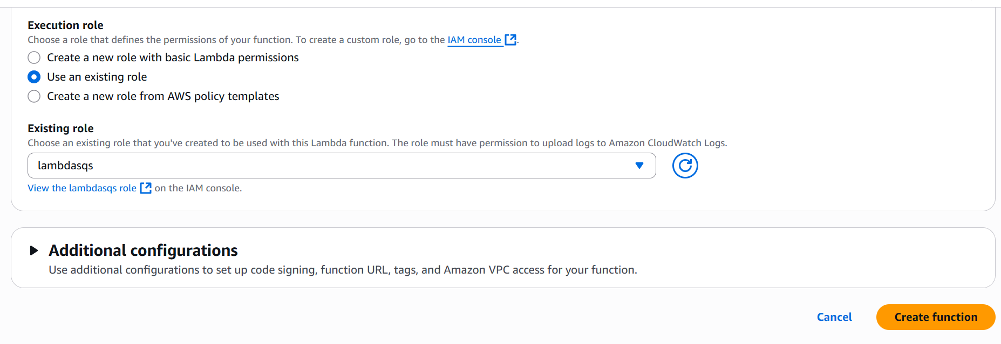

Modify below code
- Provide SNS arn
- SQS url
- 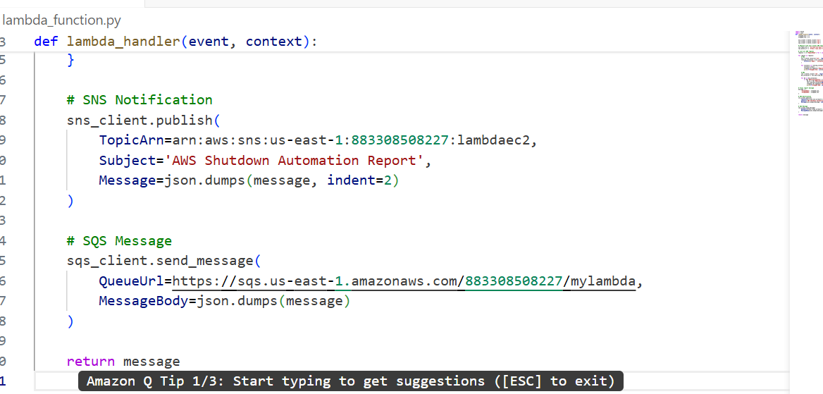

import boto3
import json

def lambda_handler(event, context):
stopped_ec2 = []
stopped_rds = []

# Clients for default region (used for SNS, SQS, and describing all regions)
ec2_client = boto3.client('ec2')
sns_client = boto3.client('sns')
sqs_client = boto3.client('sqs')

# Replace with your actual SNS Topic ARN and SQS Queue URL
sns_topic_arn = 'arn:aws:sns:us-east-1:883308508227:lambdaec2'
sqs_queue_url = 'https://sqs.us-east-1.amazonaws.com/883308508227/mylambda'

# Get list of all regions
try:
regions = [r['RegionName'] for r in ec2_client.describe_regions()['Regions']]
except Exception as e:
print(f"Error fetching regions: {e}")
return {"error": "Unable to fetch AWS regions"}

for region in regions:
print(f"Processing region: {region}")
# Stop EC2 instances
try:
ec2 = boto3.resource('ec2', region_name=region)
running_instances = ec2.instances.filter(
Filters=[{'Name': 'instance-state-name', 'Values': ['running']}]
)

for instance in running_instances:
instance.stop()
stopped_ec2.append({'Region': region, 'InstanceId': instance.id})
print(f"Stopped EC2: {instance.id} in {region}")
except Exception as e:
print(f"Error processing EC2 in {region}: {str(e)}")

# Stop RDS instances
try:
rds = boto3.client('rds', region_name=region)
db_instances = rds.describe_db_instances()['DBInstances']

for db in db_instances:
if db['DBInstanceStatus'] == 'available':
db_id = db['DBInstanceIdentifier']
rds.stop_db_instance(DBInstanceIdentifier=db_id)
stopped_rds.append({'Region': region, 'DBInstanceIdentifier': db_id})
print(f"Stopped RDS: {db_id} in {region}")
except Exception as e:
print(f"Error processing RDS in {region}: {str(e)}")

# Final message
message = {
'StoppedEC2': stopped_ec2,
'StoppedRDS': stopped_rds
}

# Publish to SNS
try:
sns_client.publish(
TopicArn=sns_topic_arn,
Subject='AWS Shutdown Automation Report',
Message=json.dumps(message, indent=2)
)
print("SNS notification sent.")
except Exception as e:
print(f"Error sending SNS notification: {str(e)}")

# Send message to SQS
try:
sqs_client.send_message(
QueueUrl=sqs_queue_url,
MessageBody=json.dumps(message)
)
print("SQS message sent.")
except Exception as e:
print(f"Error sending SQS message: {str(e)}")

return message
Test & Deploy
- Paste this code into Lambda's inline editor.
- Create Ec2 vm
- Click Deploy, then Test using {}.
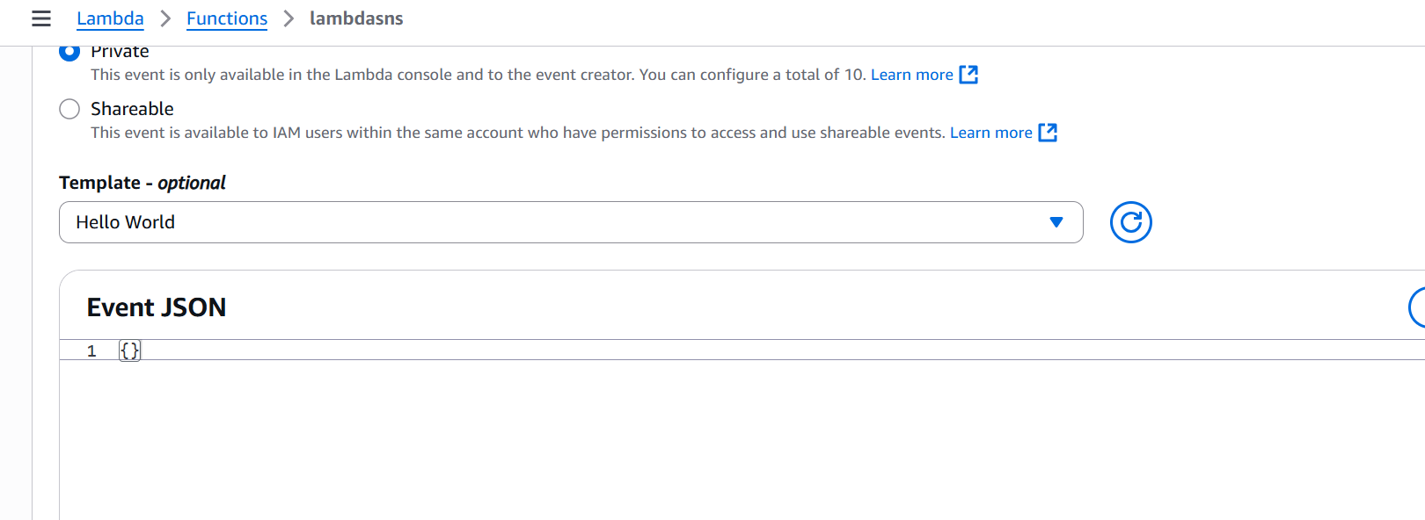
- Launch a EC2 instance
- Check CloudWatch logs, SNS email, and SQS queue for messages.
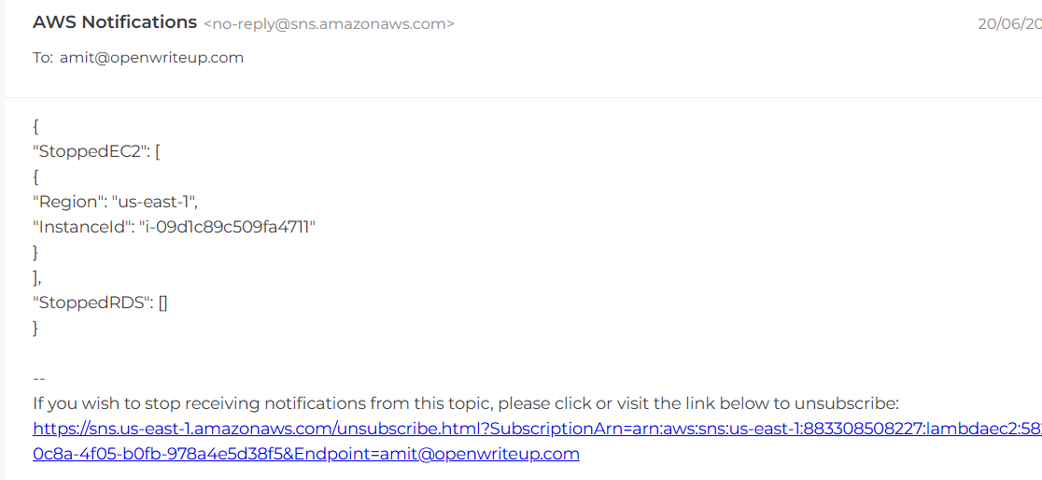

In SQS
Scroll down to the “Messages” section
You'll see sections like:
- “Send and receive messages”
- “Message retention”
- “Monitoring”
- Click on “Send and receive messages”
In the “Receive messages” section:
- Click “Poll for messages”
- You will see the messages currently available in the queue (in your case, 2).
- You can click to view the message body and metadata (like message attributes).

